Computer Vision – Task 2 + 3

Summary
This report details the methodology, implementation, and evaluation of Tasks 2 and 3 for the Computer Vision project. The objective of Task 2 is to accurately count the total number of balls on an 8-ball pool table from an input image. Task 3 expands on this by detecting the precise spatial positions of the balls using bounding boxes and utilizing these spatial layouts to perform image retrieval. The implementations leverage modern deep learning frameworks, specifically PyTorch and Ultralytics

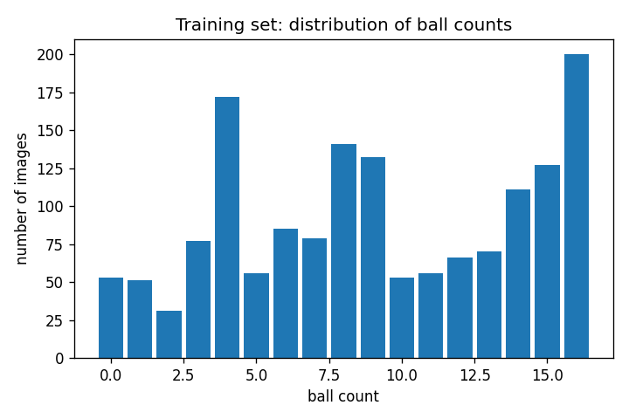
Task 2: Ball Counting (CNN-Based)
Objective and Data Distribution

The primary goal of Task 2 is to process an image of a pool table and regress the total number of balls present. Understanding the training data is critical to model performance. As illustrated in the training distribution, the dataset exhibits a natural imbalance, with most images containing between 7 and 11 balls.
Figure 1: Distribution of ball counts in the training dataset, showing a heavy concentration around mid-game states.
This distribution implies that the model will have ample examples to learn features for mid-game tables, but may struggle with edge cases (e.g., a nearly empty table or a full 15-ball break) due to a lack of representation.
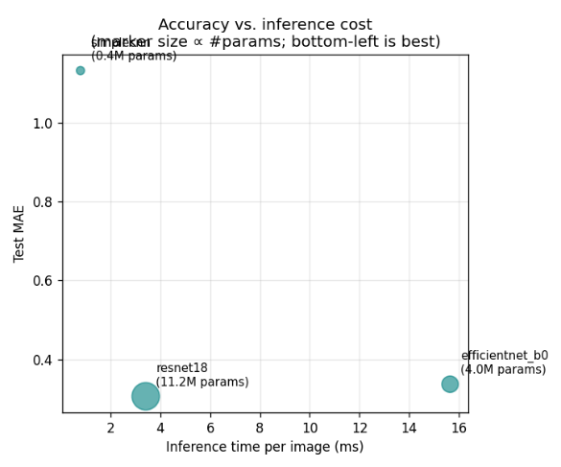
Architecture Comparison and Performance
The counting task is formulated as a regression problem using a Convolutional Neural Network (CNN). To find the optimal solution, three distinct architectures were trained and evaluated: a baseline SimpleCNN, ResNet-18, and EfficientNet-B0.
The models were evaluated not just on accuracy, but on operational efficiency. The efficiency scatter plot compares the Mean Absolute Error (MAE) against inference throughput (images per second).
Figure 2: Model efficiency comparison, mapping prediction error against inference speed.
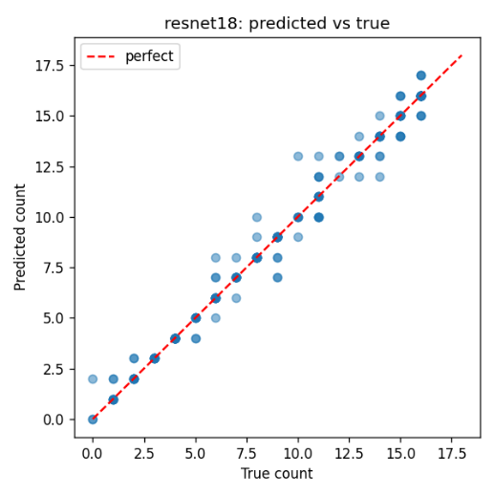
This evaluation reveals the architectural trade-offs. While smaller models may process images faster, they suffer from higher error rates. ResNet-18 was selected as the final model because it offers the optimal balance: it achieves strong convergence (as tracked via training/validation loss curves) and maintains high accuracy without an overwhelming parameter count.
The predictive accuracy of the chosen ResNet-18 model is visualized in the prediction scatter plot.
The strong diagonal alignment confirms that the model successfully generalizes the counting task. Minor outliers at the extreme high and low ends directly correlate with the underrepresented classes identified in Figure 1.
Figure 3: ResNet-18 Prediction vs. Ground Truth. Points clustered tightly along the diagonal indicate highly accurate predictions.

Hardware and Environment Optimization
To ensure stable training and inference on the available hardware, several environment configurations were explicitly handled:
- ROCm Compatibility: To force compatibility with the AMD RX 6600 GPU architecture, the environment variable HSA_OVERRIDE_GFX_VERSION was set to "10.3.0".
- Memory Management: PCIe memory segmentation faults were prevented by disabling SDMA transfers (HSA_ENABLE_SDMA="0").
- DataLoader Stability: OpenCV's internal threading was completely disabled (cv2.setNumThreads(0)) to prevent segmentation faults occurring within PyTorch's DataLoader workers.

Task 3: Ball Detection and Image Retrieval

Part A: Ball Detection
Objective: Detect the position of the balls on the pool table using bounding boxes classified under a single class (Ball).
Model Comparison: The implementation provides a fair, side-by-side comparison of two distinct detector families using the third-party ultralytics package:
- YOLO11 (yolo11s): A fast, one-stage, anchor-free CNN baseline.
- RT-DETR (rtdetr-l): A modern Transformer-based detector (DETR family) that operates end-to-end without Non-Maximum Suppression (NMS) and trains effectively on smaller datasets.
Dataset: Both models were trained and evaluated on the exact same dataset splits to guarantee fairness. The dataset distribution consists of 1,560 training images, 195 validation images, and 196 test images. The data averages approximately 8.7 to 9.1 balls per image across the splits.
Training Configuration: Images were resized to a shared resolution of 640x640.
- To accommodate the 8 GB VRAM limit, the lightweight YOLO model utilized a batch size of 8, while the heavier RT-DETR model was restricted to a batch size of 2.
- Training was set for an upper bound of 100 epochs, utilizing an early stopping patience of 20 epochs to halt training when validation improvements ceased.

Part B: Image Retrieval
Objective: Image retrieval focuses on finding one or more images from a candidate pool that are most like a query image.
Methodology: Because the dataset does not possess supervised ground-truth catalogues for pool table similarity, an alternative structural method was developed. Rather than relying solely on pixel-level features, the system feeds the detected ball positions from the detection phase into the retrieval pipeline.
Similarity Computation: Each pool table is represented by its unique set of ball centroids. The algorithm then computes the similarity by calculating the Chamfer distance between the point set of the query image (query_pts) and the point sets of the candidate images (pool_pts).
Retrieval Pool: Due to the relatively small size of the dataset, the entire training data partition (gathered seamlessly from the scattered train/valid/test folders) is considered as the retrieval pool. A layout_topk function is utilized to sort these distances and return the top k most structurally similar tables.

Conclusion
The implementation successfully divides the problem into discrete, highly optimized tasks. Task 2 proves that CNNs (specifically ResNet-18) can be tuned to accurately regress or classify the total count of objects in a scene. Task 3 successfully contrasts the strengths of CNN-based (YOLO) and Transformer-based (RT-DETR) object detectors. Furthermore, by passing the detected bounding box centroids into the retrieval algorithm and utilizing the Chamfer distance, the pipeline elegantly links the detection and retrieval halves of the project to find spatially similar pool tables without requiring labeled similarity ground-truths.

Team Members
Gonçalo Marques - up202206205
Miguel Guerrinha - up202205038
Miguel Duarte - up202206102
Rui Cruz - up202208011

